NAME: P. MOHIT KARTHIK ID NO: 2520080059

PRACTICAL WEEK 1

Task 1: Develop a C program that demonstrates how a Linux operating system executes a command entered by a user that 1. Accept a Linux command as input. 2. Create a child process using fork(). 3. Execute the command in the child process using an appropriate exec() system call. 4. Allow the parent process to wait for the child using wait (). 5. Display the Process ID (PID) of both parent and child processes.
- Write a C code to create a process using fork() system call.
- Read the user input as shell command.
- Use a system call exec() to execute the shell command.
- Use a wait() system call for waiting a parent process.
- Display the PIDs of parent and child processes.

1) Create a file
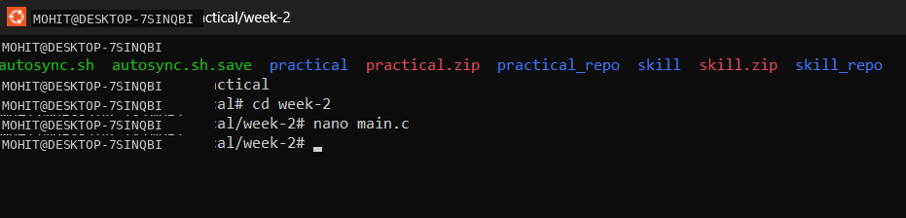
Then press enter to open command
2) write a code
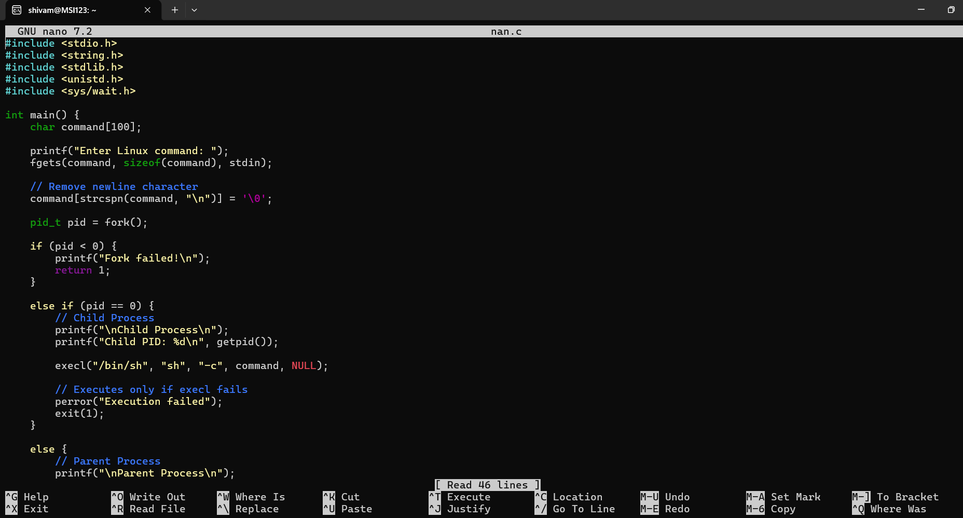
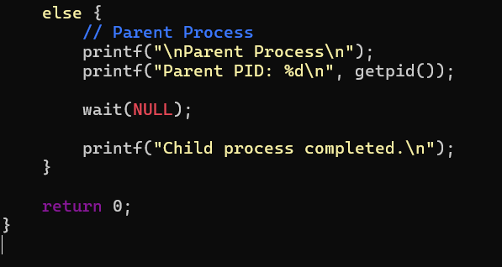
- To save press control O
- To come back to shell press control X
- Then for compilation write a command
gcc filename.c -o filename
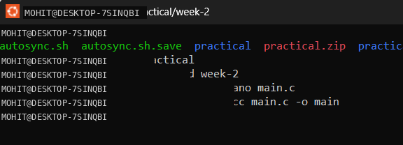
Then press enter then to view a output write a command
./filename
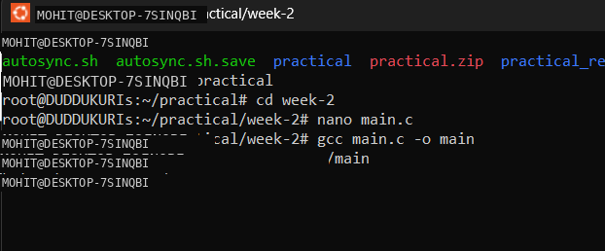
Then you will be asking to enter linux command to view the output
In ENTER LINUX COMMAND: enter either "ls” command (or) “pwd” command to see the output of your code
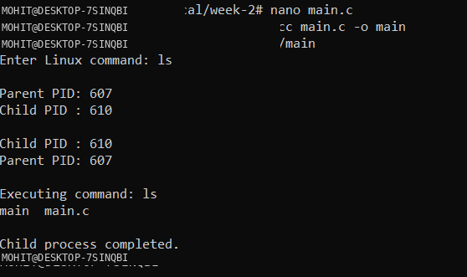

Task-2: Using Linux terminal commands (uname, lscpu, ps, top), investigate the relationship between hardware resources and operating system services. Prepare a report explaining how the OS abstracts CPU, memory, storage, and I/O devices.
